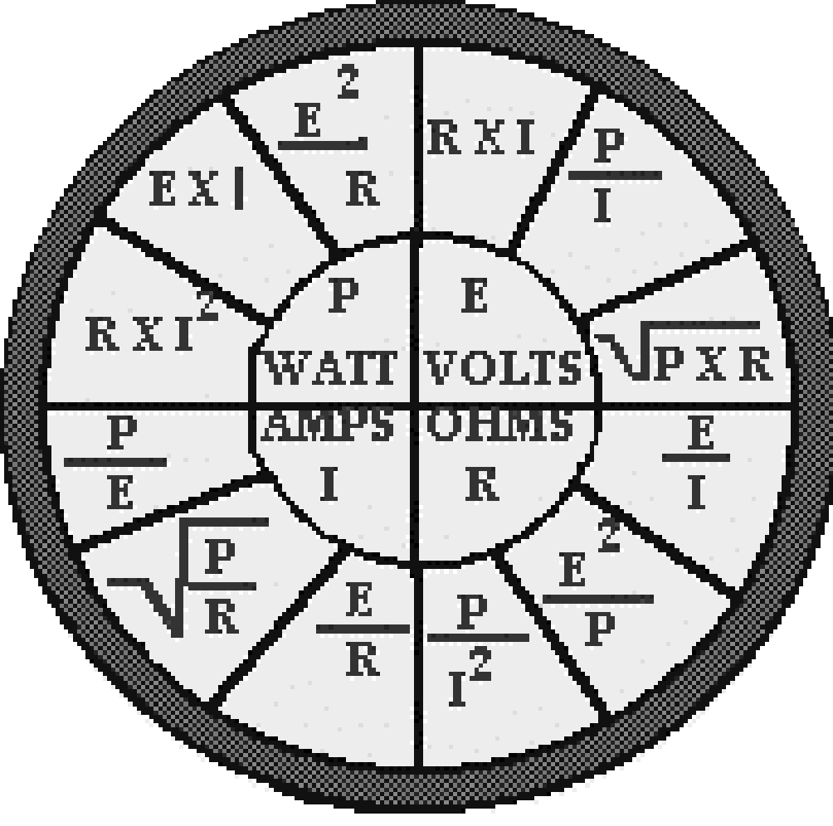
AREA III (LANE COUNTY)
Joint Apprenticeship Training Committee
(J.A.T.C.)

APPLICATION PRIVATE FOR CONSIDERATION

NOTICE TO APPLICANTS

You are not required to give information on this form where such information is expressly prohibited by Federal, State or local laws and the applicant may exclude those responses that may indicate race, creed, sex, marital status, age, color, national origin, disabilities, military status, ethnicity or union affiliation.

Our employment practices are in full accord with State and Federal laws, which prohibit discrimination because of race, color, religion, age, sex, national origin, membership and activities on behalf of a labor organization, disabilities, or ethnicity.

This application may not be reproduced and must be completed at our office or designated site.

Important! This employment application will only be valid for 2 years from application date. Incomplete applications will not be considered. If a question does not apply to you, print NA, which means “not applicable”. False or misleading statements on this employment application will result in its removal from consideration for any current or future employment opportunities with this company.
FOR OFFICE USE ONLY

MINIMUM QUALIFICATIONS FOR APPLICANTS
2. The minimum qualifications for applicants are:
a. Age: Applicant shall be at least eighteen (18) years of age at time of registration.
b. Education:
1. Applicants shall be high school graduates or have a certificate of equal value, General Equivalency Degree (GED);
2. Applicants who are high school graduates shall furnish a transcript of their high school. GED Applicants shall furnish a copy of their test scores;
3. A grade point average of 2.0 (C average) shall be required. Additional schooling will be considered in determining the GPA if submitted in transcript form from accredited schools.
4. Subjects: Completion of a minimum of one year of high school algebra with a grade of C or better or one post high school algebra course (equivalent to one year high school algebra) with a grade of C or better.

NOTE: A current valid Oregon driver's license may be required for employment.

Name: (Last Name) (First Name) (MI) | Social Security Number
Mailing Address: | Phone (Area Code) Number
City State Zip | Email Address

SEX |  | Race/Ethnicity |  |  |  |  |  |  | Date of Birth |  |  |  | Veterans Status
M | F | Wh | BL | AI | AS | AI |  | HI | MM | DD | YYYY |  | Are you a Veteran?  Yes No
Service Branch: |  |  |  |  |  |  | Discharge Date: |  |  |  |  | Length of Service:

Veterans please check one: • Plan • Do not plan to use GI Benefits

EDUCATION: (Circle Highest Completed) 9 10 11 12 GED A.S. B.S. Trade School

Diploma: Yes/No

Have you ever filed an application with us before?  If Yes, give date:______________________ | Yes      No
Are you currently employed with an AREA III Training Agent (IEC Electrical Contractor)?  If Yes, give Name of Company:________________________________ | Yes      No
Are you currently employed? | Yes      No
May we contact your present employer? | Yes      No
Do you have your own transportation (Vehicle) | Yes No
Soonest date would you be available for work?
Have you been a Registered Apprentice in this or any other Area? | Yes No
Are you currently on “lay-off” status and subject to recall? | Yes      No
Can you travel if a job requires it? | Yes      No
Travel outside of Oregon? | Yes      No
Do you hold a valid driver’s license? Driver’s Lic. No. and State: | Yes      No
If you are a referral, who referred you to us?
Are you available for overtime or shift work? | Yes      No

EDUCATION

SCHOOL | Name and Address  of School | Course of Study | Years  Completed | Diploma  Degree
High
School
College
Other
(Specify)

EMPLOYMENT EXPERIENCE

Start with your present or last job. Include any job-related military service assignments and volunteer activities. You may exclude organizations, which indicate race, color, religion, gender, national origin, disabilities or other protected status.

Employer |  | Dates Employed  From To |  | Work Performed
Address
Telephone Number(s)
Job Title | Supervisor
Reason for Leaving
Employer |  | Dates Employed  From To |  | Work Performed
Address
Telephone Number(s)
Job Title | Supervisor
Reason for Leaving
Employer |  | Dates Employed  From To |  | Work Performed
Address
Telephone Number(s)
Job Title | Supervisor
Reason for Leaving
Employer |  | Dates Employed  From To |  | Work Performed
Address
Telephone Number(s)
Job Title | Supervisor
Reason for Leaving
If you need additional space, please continue on a separate sheet of paper.

ADDITIONAL INFORMATION

Other Qualifications
Summarize special job-related skills and qualifications acquired from employment or other experience. Especially construction skills in areas other than the primary skill applied for on this application (multi-skill).

Special Licenses

State any additional information you feel may be helpful to us in considering your application.

Note to Applicants: DO NOT ANSWER THIS QUESTION UNLESS YOU HAVE BEEN INFORMED ABOUT THE REQUIREMENTS OF THE JOB FOR WHICH YOU ARE APPLYING.

Are you capable of performing in a reasonable manner, with or without a reasonable accommodation, the activities involved in the job or occupation for which you have applied? A description of the job or occupation is available.
Yes No

REFERENCES: Give the names of three persons not related to you, whom you have known at least one year.
NAME:____________________________________________________________________________

ADDRESS:______________________________________________________ STATE__________ ZIP_______________

POSITION:____________________________________________________ TELEPHONE # _______________________

NAME:____________________________________________________________________________

ADDRESS:______________________________________________________ STATE__________ ZIP_______________

POSITION:____________________________________________________ TELEPHONE # _______________________

NAME:____________________________________________________________________________

ADDRESS:______________________________________________________ STATE__________ ZIP_______________

POSITION:____________________________________________________ TELEPHONE # _______________________

APPLICANT’S STATEMENT

PLEASE READ THE FOLLOWING STATEMENTS CAREFULLY BEFORE
SIGNING THIS APPLICATION. ONLY THOSE APPLICATIONS THAT ARE SIGNED AND DATED ARE CONSIDERED VALID. IF YOU HAVE ANY QUESTIONS REGARDING THIS STATEMENT, PLEASE ASK THE BEFORE SIGNING.
I certify that all answers and statements I have made on this application (and resume or other supplementary materials) are true and complete without omissions. I understand that any false information will be grounds for refusal to hire or for immediate discharge if currently employed by an Area III Training Agent. I authorize any persons or Training Agent affiliated with Mid-Oregon IEC to give complete information and records regarding my Employment, Education, Character and qualifications while registered as an Apprentice.

YES • NO • __________Initial

I understand that I am responsible for familiarizing myself with all Policies and Standards of the Area III JATC and the company (Training Agent) I am employed by, as they presently exist or are later modified.

YES • NO • __________Initial

I further recognize that my employment with an Area III Training agent can be terminated at any time, at the discretion of the Training Agent (employer) or at my option, without notice, except as specifically set forth in writing in a current individual employment agreement signed by the president of the company I am employed with.

YES • NO • __________Initial

I understand that incomplete employment applications or applications missing required documentation will not be considered.

YES • NO • __________Initial

Any offer of employment tendered to the applicant by an Area III Training Agent is conditional and may be contingent upon other requirements such as successful completion of a drug test and background information. Ratio verification. Out of work apprentice pool.

YES • NO • __________Initial

This application will be valid until the next open enrollment period. Remaining on the list of eligible applicants is contingent upon complete and accurate contact information. Failure to inform Mid-Oregon IEC of address and phone number changes or failure to return required letters of intent will result in removal from the list. ___________Initial

I have read, understand and agree with the above.

___________________________________________________ ___________________________________
Signature of Applicant Date

AREA III Statement of Understanding

Please answer the following as they help us to better disseminate information regarding the Apprenticeship Training Program.

How did you hear about the Mid-Oregon IEC Apprenticeship Program?
(Circle all that Apply)

Newspaper Flyer Internet TV Radio School Counselor__________________(Name)

Workforce Network Employment Division Word of Mouth___________________(Name)

Civic Organization ___________________(Name) Apprentice________________________(Name)

Other:_______________________________________________________Please list

Please read and initial the following:

_______ __ I am aware that I am responsible for keeping the program coordinator informed of ANY change in Address or Phone number.

__________ I have read and understand the qualifications for entry.

__________ I understand that if I do not provide adequate documentation of the programs minimum entry requirements, I WILL NOT be considered for entry.

_________ I have a COPY of the AREA III Initial Ranking and placement policy.

_________ I understand how the ranking and selection process works.

_________ I understand that refusal of employment opportunities MAY be grounds for removal from the ranked pool of applicants.

_________ I have been informed of the programs Math Placement policy and understand that I have to place at or above Math-60 (LCC Placement Exam) in order to participate in Classroom Training.

__________ I understand that I may provide additional Ranking documentation at ANY time. And that that documentation will effect my position in ONLY the ranked pool.

Signature of Applicant:_____________________________________________________

Date:______________________

